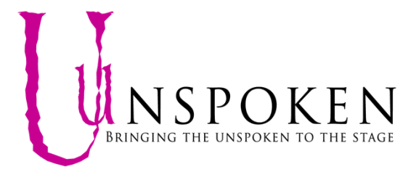

Standing order form

To set up a regular standing order donation, please complete this form and return to kate.unspoken@gmail.com

Our Details
Account Name:UNSPOKEN Account Number:77415480 Sort code: 090153

Your Details
Title:
Forename:
Surname:
Tel:
Email:
We promise not to share any of your details with third party organisations

I would like to make a regular gift via Standing Order of:

£5 £10 £20 Other _____ Monthly

We will debit the above amount from your account on or around the 1st of each month

Bank Details

Full Name of your bank/ building society
Address:
Postcode:

Name(s) of account holder(s):

Account No:
Branch sort code:

21a Muswell Road, London N10 2BJ
Email : kate.unspoken@gmail.com
The Unspoken Project is a Community Interest Company : 09176073

